Material 1 English version
Interview with researcher Heesoo Jang about benefits and risks of online platforms
Online platforms and interaction risks for children and youth
The interview was conducted by Laura Schelenz (researcher at the University of Tübingen in Germany) with Ms. Heesoo Jang in October 2023 at a conference in Minneapolis, USA.
LS: Ms. Jang, you are a researcher at the University of North Carolina Chapel Hill, and you are interested in platforms. Can you tell us: what are platforms?
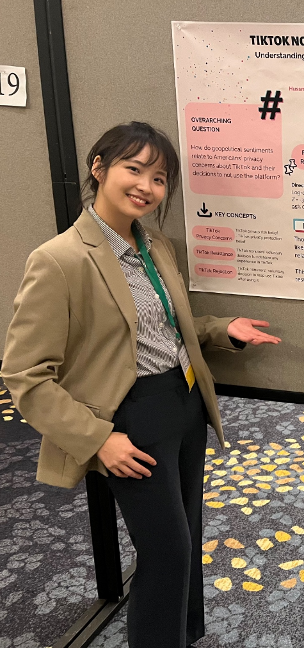
HJ: So, of course there are various definitions for platforms, but I think usually in my research area, we define platforms as an online space where people are connected with each other. So, if there is an online space that only one person is in and no interaction is happening, we don't call that a platform. We call it a platform when an online space is mediating different people and allowing interactions in different ways.

LS: Why do you think that platforms are so widely used? And do you have an example for a popular platform?
HJ: I think the attractiveness of platforms comes from not having a limitation in time and space because people are so used to being restricted from physical boundaries. If you live in a different location, then you have difficulty in reaching out to each other and communicating. Sometimes there are delayed responses if you're going through emails. I guess telephones have helped in that a bit, but there is a restriction in modality when it comes to telephones. It's only voice input and voice output. But when it comes to online spaces, I think a lot of people feel freedom around it. So, people can use different modalities, not only text, but voice, image, emojis, and other types of modalities that are used in communication. And I think that creates a lot of open space for communication, new ways to communicate different issues. I'm also thinking about the political participation context here, where people start talking about issues that are difficult to talk about in person. Platforms create online spaces and safe spaces to talk about difficult issues. And in South Korea, Kakao Talk is, I wouldn't say it's like a social media platform, but it has been going in that direction – it started as a direct messaging service. But one of the reasons Kakao Talk caught on popularity in the nation is because it was free. As long as you had access to Wi-Fi, you could use it for free. And back then, text messages cost, I would say, $0.3 per text. So, if you were texting each other constantly, that could pile up and get really expensive. And so, there were problems around who can access this, who can afford this. And communication was really bounded to this limit of who has enough capital to do it. And so, I think in that sense, people found social media – even all kinds of platforms – really freeing in the sense that as long as you have Wi-Fi, as long as you have access to the Internet, you can talk with anyone. Also creating new spaces for experimenting different kinds of communications that didn't exist in the past.
Heesoo Jang researches online social media platforms like TikTok at the University of North Carolina at Chapel Hill in the USA. This photo shows Jang present an academic poster at an international conference.
Photo: private

LS: And these are some of the benefits. But do you also see risks when people are interacting with other users and with platforms?
HJ: Of course. Yes. So, the problem of platforms is: anyone can use them. And that includes not only users who have good intentions, who want to connect with each other for the social good, but also users who are trying to take advantage of the platform, make money out of it, and do not care about whether they're causing harm to the community or other people. And sometimes this is done unintentionally. That people, users, do not know they're harming other users. But sometimes that is very intentional! So one of the case studies that I've been working on for the past couple of years is a digital sex trafficking ring in South Korea, where sex perpetrators have been using all kinds of different digital platforms to identify victims and then online grooming children and getting children to come into this unsafe space where they're exploited and abused by the sex perpetrators only for the perpetrators to make profit out of abusive videos. So, I guess like a lot of risks come from the fact that platforms have been relying solely on the user’s good intentions, but they don't have any restrictions or any means to criminally prosecute bad users. It's really hard to do that, especially when the notion of an open internet is built on this concept of anonymous users. It's really hard to do that. Also, another dimension that makes it really hard to regulate platforms include the transnational character of platforms. A lot of big tech companies are majorly headquartered in the West, but then they operate in countries outside of the West and even mostly in the Majority World. And these platforms change how businesses operate, how people communicate with each other, and have so many impacts and implications for civic life of people outside of the Western countries. But then the policies and restrictions for platforms are SOLELY made in the Western world.

LS: Thank you for explaining a little bit to us what platforms are, and about your research. Do you have maybe some recommendations for children in particular? Because you have shown that children are particularly vulnerable when it comes to interacting with these platforms, and sometimes they might be abused, sometimes they might be extorted. So, is there a way that children can protect themselves online?
HJ: Sure. I guess one thing I really want to emphasize is that when we refer to online spaces as this one term called the Internet, it feels like there is only one homogeneous space, which is not true. What we call the Internet includes different spaces with varying levels of safety. So, some spaces are definitely safe for children, safe for marginalized communities, while other spaces are going to be harmful and dangerous. And so, knowing and being aware that there can be unsafe spaces on the Internet is important – and also remembers that not all users come with good intentions to those spaces. And sometimes people are not authentic in online spaces.

What I mean by this is that if, for example, you're on a game and you play with a user who admittedly argues that they are the same age as you, that might not be true, and there is no way to verify this information. So just being cautious about whatever claims other users make. I think this is where we also talk about fact-checking a lot. But there is no way to fact-check other users when you're a user in an online space. So just being cautious about the intentions of users when other users approach you. Also, I would say there are various functions that designers and companies come up with regarding platforms to protect their users, but it's really hard to navigate those. There are helpful tools, for example, there are YouTube videos to learn about safety measures. So just learning about what kind of filters or what kind of safety functions are there on the platform you use, and then really trying to learn about them and use them in real life. Because even though companies decide to make various filters and safety functions, if users don't use them, it's like they're non-existent. And if you're a child or a teenager, I think you should rely a lot on your teachers or parents to discuss this and talk about ways that you can keep your online space safe while also enjoying the freedom that online spaces give you to express yourself.

